Report For Graduation Project

Created For Professor **Mahmoud Eid** by Team Members:

* Mohamed Hisham Abdelzaher
* Yousef Mohamed Abd El-Hay
* Abdelrahman Mostafa Mohamed
* Beshoy Medhat Sadeq
* Rina Khaled Ahmed
* Shereen Ashraf Ahmed

GitHub: <https://github.com/MH0386/graduation_project>

Email: [alpha-AI@googlegroups.com](mailto:alpha-AI@googlegroups.com)

# Frame Rate Enhancer

Video frame rate enhancement by artificial intelligence is a technique that uses deep learning algorithms to generate new frames in between existing frames of a video, resulting in a higher frame rate and smoother motion. There are several approaches to video frame rate enhancement using AI, including video frame interpolation (VFI) and video super-resolution (VSR). One recent study proposed a one-stage space-time video super-resolution framework that can directly reconstruct a high-resolution slow-motion video sequence from a low-resolution and low-frame-rate video. The proposed framework uses a feature temporal interpolation module to temporally interpolate LR frame features from the missing LR frames, capturing local temporal contexts. The results show that the proposed framework achieves better qualitative and quantitative performance on both clean and noisy LR frames and is several times faster than recent state-of-the-art two-stage networks. Another study proposed an efficient face detection and recognition approach using machine learning and high-performance computing that can recognize faces with huge changes. The study used a convolutional neural network (CNN) and the recurrent neural network's subpart long-short-term memory technique to improve the reorganization procedure. Video frame interpolation aims to synthesize nonexistent frames in between the original frames. While significant advances have been made in recent deep convolutional neural networks, the quality of interpolation is often reduced due to large object motion or occlusion. One study proposed a video frame interpolation method that explicitly detects occlusion by exploring depth information. The proposed model then warps the input frames, depth maps, and contextual features based on the optical flow and local interpolation kernels for synthesizing the output frame. It is difficult to rank the accuracy of each AI-based video frame interpolation model as it depends on several factors such as the complexity of the video, the amount of motion in the video, and the specific parameters used. However, here is a list of the models based on their popularity and general effectiveness:

* [DVF](https://paperswithcode.com/paper/video-frame-synthesis-using-deep-voxel-flow) (**D**eep **V**oxel **F**low)
* [DAIN](https://paperswithcode.com/paper/depth-aware-video-frame-interpolation) (**D**epth-**A**ware Video Frame **In**terpolation)
* [RIFE](https://paperswithcode.com/paper/rife-real-time-intermediate-flow-estimation) (**R**eal-Time **I**ntermediate **F**low **E**stimation)

* [Super](https://github.com/avinashpaliwal/Super-SloMo) SloMo
* [RAFT](https://github.com/princeton-vl/RAFT) (**R**ecurrent **A**ll-Pairs **F**ield **T**ransforms)

* [TecoGAN](https://github.com/thunil/TecoGAN) (**Te**mporally **Co**herent **GAN**)
* [EDVR](https://paperswithcode.com/paper/edvr-video-restoration-with-enhanced) (**E**nhanced **D**eep **V**ideo **R**estoration)
* CAIN (**C**ontent-**A**ware **I**npainting **N**etwork)
* [MEMC-Net](https://paperswithcode.com/paper/memc-net-motion-estimation-and-motion-1) (**M**otion **E**stimation and **M**otion **C**ompensation **Net**work)

* [SepConv](https://paperswithcode.com/method/depthwise-separable-convolution) (**Sep**arable **Conv**olutional Networks)

* [Softmax](https://github.com/sniklaus/softmax-splatting) Splatting (**SS**)

* [TOFlow](https://paperswithcode.com/paper/video-enhancement-with-task-oriented-flow/review/) (**T**ask-**O**riented **Flow**)

In summary, video frame rate enhancement by artificial intelligence is a promising technique that can generate new frames in between existing frames of a video, resulting in a higher frame rate and smoother motion. There are several approaches to video frame rate enhancement using AI, including video frame interpolation (VFI) and video super-resolution (VSR). These approaches use deep learning algorithms to improve the quality of video frames and can be applied to various applications, such as face detection and recognition and image and video quality enhancement.

## Comparisons

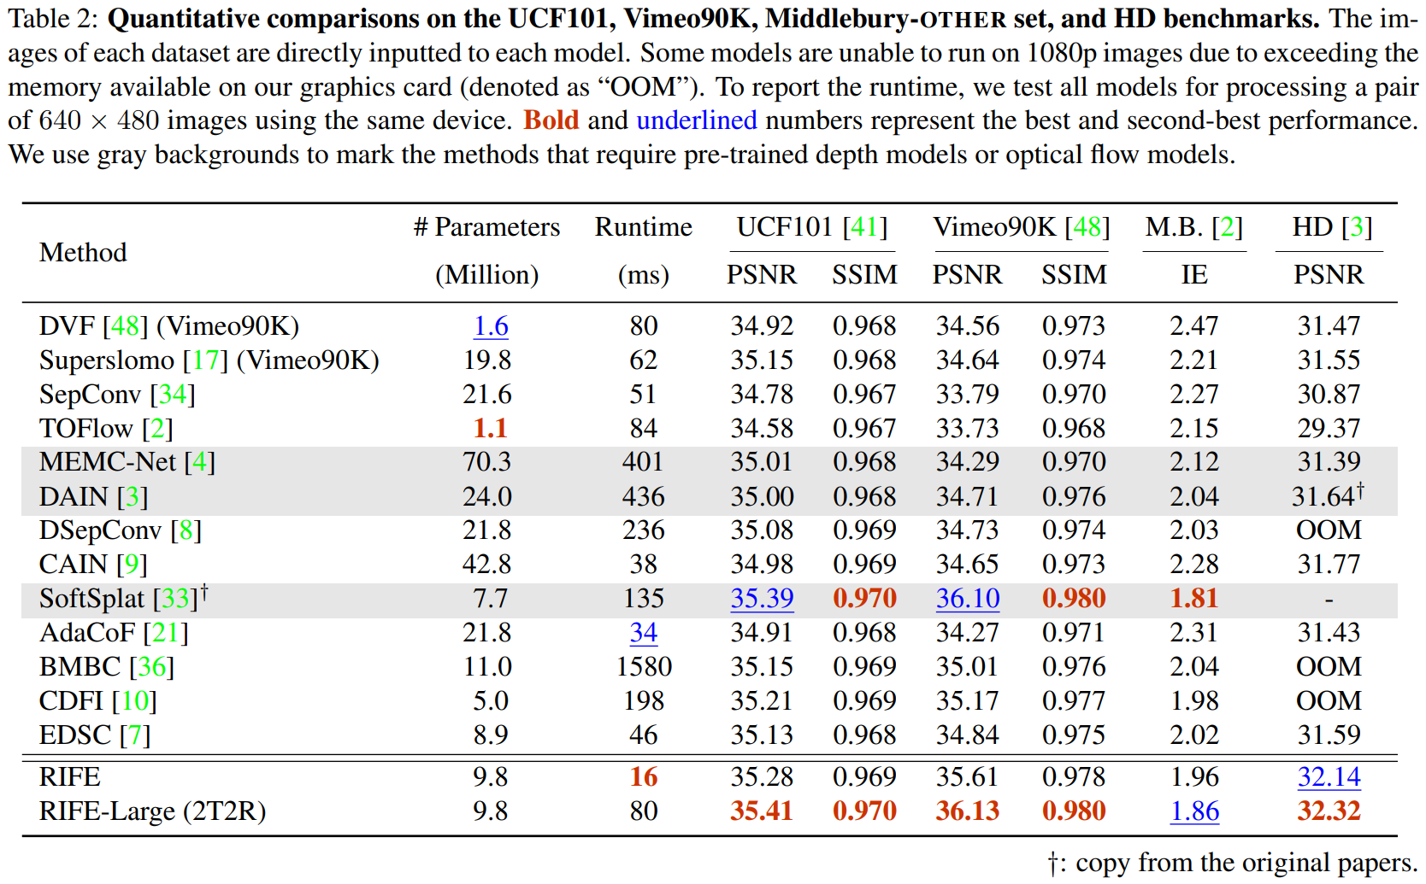

As we can see, RIFE is better than others. It has an excellent **P**eak **S**ignal-to-**N**oise **R**atio (PSNR) and **S**tructural **S**imilarity **I**ndex **M**easure (SSIM).

RIFE (Real-Time Intermediate Flow Estimation) is a video frame interpolation algorithm that uses a neural network to directly estimate intermediate flows from coarse to fine. This allows it to achieve much faster speeds than other methods. RIFE is a real-time algorithm that can process 720p videos at 30 frames per second. Additionally, RIFE is designed to directly estimate intermediate flows from coarse to fine, which can lead to better accuracy compared to other methods that first estimate bi-directional optical flows and then linearly combine them to approximate intermediate flows. According to the search results, RIFE is 4–27 times faster than the popular SuperSlomo and DAIN methods while producing better results. Additionally, RIFE is the first flow based and real-time VFI algorithm that processes 720p videos at 30 frames per second. Therefore, RIFE is a faster and more efficient VFI algorithm than other methods.

In conclusion, RIFE is a fast and accurate video frame interpolation algorithm that is suitable for real-time applications.

## Reference

* [RIFE Explained | Papers with Code](https://paperswithcode.com/method/rife)
* [RIFE AI interpolation - SmoothVideo Project (SVP)](https://www.svp-team.com/wiki/RIFE_AI_interpolation)
* [GitHub: megvii-research/ECCV2022-RIFE: ECCV2022 - Real-Time Intermediate Flow Estimation for Video Frame Interpolation](https://github.com/megvii-research/ECCV2022-RIFE)
* [RIFE, Real-Time Intermediate Flow Estimation for Video Frame Interpolation](https://www.linkedin.com/pulse/rife-real-time-intermediate-flow-estimation-video-frame-westveer)
* [Real-Time Intermediate Flow Estimation for Video Frame Interpolation](https://arxiv.org/abs/2011.06294)
* [RIFE: Real-Time Intermediate Flow Estimation for Video Frame Interpolation | Papers with Code](https://paperswithcode.com/paper/rife-real-time-intermediate-flow-estimation)
* <https://www.arxiv-vanity.com/papers/2011.06294>
* [RIFE AI interpolation - SmoothVideo Project (SVP)](https://www.svp-team.com/wiki/RIFE_AI_interpolation)
* <https://arxiv.org/pdf/2105.13482.pdf>
* [Video Frame Interpolation | Papers with Code](https://paperswithcode.com/task/video-frame-interpolation)
* [Depth-Aware Video Frame Interpolation](https://arxiv.org/abs/1904.00830)
* [Transform Network Architectures for DL based End-to-End Image/Video Coding in Subsampled Color Spaces](https://arxiv.org/abs/2103.01760)
* https://pubmed.ncbi.nlm.nih.gov/32225742
* [IFRNet: Intermediate Feature Refine Network for Efficient Frame Interpolation](https://arxiv.org/abs/2205.14620)
* https://pubmed.ncbi.nlm.nih.gov/34346905
* [XVFI: eXtreme Video Frame Interpolation](https://arxiv.org/abs/2103.16206)
* [FILM: Frame Interpolation for Large Motion](https://arxiv.org/abs/2202.04901)
* [Asymmetric Bilateral Motion Estimation for Video Frame Interpolation](https://arxiv.org/abs/2108.06815)
* <https://www.ncbi.nlm.nih.gov/pmc/articles/PMC9163436>
* [SuperFast: 200× Video Frame Interpolation via Event Camera](https://pubmed.ncbi.nlm.nih.gov/36417747)
* [Time Lens++: Event-based Frame Interpolation with Parametric Non-linear Flow and Multi-scale Fusion](https://arxiv.org/abs/2203.17191)
* [Multiple Video Frame Interpolation via Enhanced Deformable Separable Convolution](https://arxiv.org/abs/2006.08070)
* [TimeLens: Event-based Video Frame Interpolation](https://arxiv.org/abs/2106.07286)
* [Enhanced Motion-Compensated Video Coding with Deep Virtual Reference Frame Generation](https://pubmed.ncbi.nlm.nih.gov/31059444)
* <https://www.ncbi.nlm.nih.gov/pmc/articles/PMC9480984>
* [Deep Learning for Content-based Personalized Viewport Prediction of 360-Degree VR Videos](https://arxiv.org/abs/2003.00429)
* [Many-to-many Splatting for Efficient Video Frame Interpolation](https://arxiv.org/abs/2204.03513)
* [PointINet: Point Cloud Frame Interpolation Network](https://arxiv.org/abs/2012.10066)
* [Learning Spatio-Temporal Down sampling for Effective Video Upscaling](https://arxiv.org/abs/2203.08140)
* [Unifying Motion Deblurring and Frame Interpolation with Events](https://arxiv.org/abs/2203.12178)
* [Power Efficient Video Super-Resolution on Mobile NPUs with DL, Mobile AI & AIM 2022 challenge](https://arxiv.org/abs/2211.05256)
* [ML Enhances Algorithms for Quantifying Non-Equilibrium Dynamics in Correlation Spectroscopy Experiments to Reach Frame-Rate-Limited Time Resolution](https://arxiv.org/abs/2201.07889)
* [Blurry Video Frame Interpolation](https://arxiv.org/abs/2002.12259)
* [Softmax Splatting for Video Frame Interpolation](https://arxiv.org/abs/2003.05534)
* [Inter-slice image augmentation based on frame interpolation for boosting medical image segmentation accuracy](https://arxiv.org/abs/2001.11698)
* [Artificial Intelligence based Video Codec (AIVC) for CLIC 2022](https://arxiv.org/abs/2206.13934)
* [Wyner-Ziv video coding with classified correlation noise estimation and keyframe coding mode selection](https://pubmed.ncbi.nlm.nih.gov/21382768/)
* [FISR: Deep Joint Frame Interpolation and Super-Resolution with a Multi-scale Temporal Loss](https://arxiv.org/abs/1912.07213)

## Data

* **Adobe240-FPS**: A dataset released by Adobe Systems that has high-frame-rate videos for training and evaluation.
* **Middlebury**: The Middlebury dataset is a popular benchmark in computer vision, including video frame interpolation tasks. It provides a variety of high-quality video sequences with ground-truth frames.
* **Vimeo-90K**: A large-scale video dataset created by Vimeo with approximately 90,000 video clips with diverse content.
* [**UCF101**](https://www.kaggle.com/datasets/pevogam/ucf101): The UCF101 dataset originally consisted of 101 action categories, but it can also be used for video frame interpolation tasks. It has a wide range of videos from various sources.

# Handwritten BCI Recognition

Brain-computer interfaces (BCIs) allow people with disabilities to communicate and control devices using their thoughts. Handwritten BCIs are easy to use and can be used by people with a wide range of disabilities. However, they can be slow and inaccurate and require electrodes to be worn on the head. Handwritten BCI Recognition is a BCI system that uses brain signals to recognize handwritten letters and symbols. It could revolutionize how people with disabilities interact with computers. The system is still in development, but it has the potential to make a real difference in people's lives.

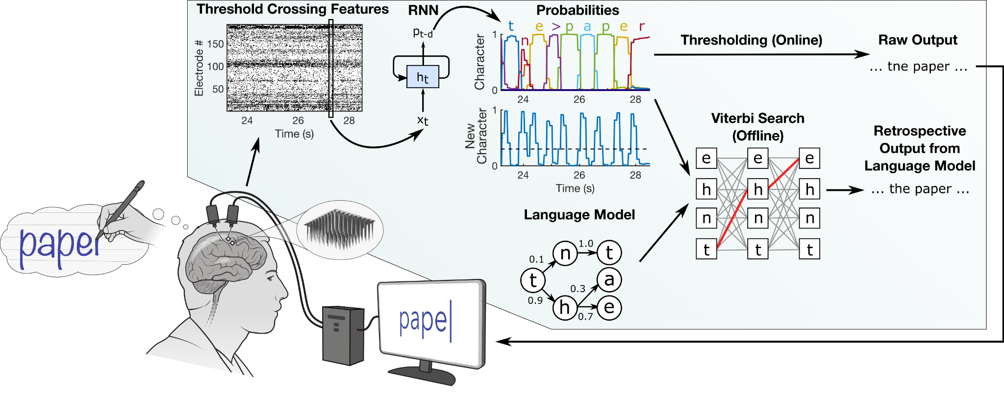

A great deal of research has been conducted on handwritten brain-computer interfaces (BCIs) in recent years. One of the most important challenges in this area is developing algorithms that can accurately decode handwriting from brain signals. Several different algorithms have been developed, but none of them are perfect. Another challenge is developing electrodes that are comfortable and easy to wear. Electrodes that are too tight can cause pain, while too loose electrodes can lead to poor signal quality. There are several approaches to recognizing handwriting using neural signals. One approach involves using non-invasive neural datasets, such as electroencephalography (EEG), to recognize handwritten characters. Another approach involves using invasive neural datasets, such as intracortical BCI, to decode imagined handwriting into real-time text. Machine learning methods are commonly used for training neural signals for handwriting recognition. These methods include classical classification methods and deep learning methods. Preprocessing techniques and feature extraction methods are also used to improve the accuracy of handwriting recognition. Finally, researchers are working on developing algorithms that can be used to control a variety of devices. This includes computers, wheelchairs, and prosthetic limbs.

Handwritten BCIs have the potential to be used in a variety of applications. One of the most obvious applications is for people with disabilities who have difficulty communicating or using their hands. Handwritten BCIs could allow these individuals to type text, control a computer, or even drive a wheelchair. Handwritten BCIs could also be used in educational settings. For example, they could be used to help students with dyslexia or dysgraphia improve their handwriting. Finally, handwritten BCIs could be used in entertainment settings. For example, they could be used to control video games or create art.

The accuracy of Handwritten BCI Recognition models has been the subject of several studies. The accuracy of these models varies depending on the dataset used, the type of model, and the specific application. For example, a study on handwritten mathematical symbol recognition proposed a context-aided correction (CAC) model that improved the recognition accuracy of handwritten mathematical symbols. Another study used a convolutional neural network (CNN) for image classification and reported an accuracy of 98.30% for recognizing handwritten digits. Additionally, a study proposed a novel handwritten Turkish letter recognition model based on CNN and achieved an accuracy of 96.07%. A custom-tailored CNN model with two different datasets of handwritten images, i.e., Kaggle and MNIST, respectively, was proposed in another study, which achieved higher accuracies than state-of-the-art models. Finally, a study on financial handwritten digit recognition reported that the current handwritten digit recognition technology can cause problems such as abnormal recognition and recognition errors, reducing recognition accuracy. The study proposed a deep learning model and control variable methods to explore the impact of different parameters on the accuracy of experimental results and achieve the best recognition accuracy. In summary, the accuracy of Handwritten BCI Recognition models varies depending on the specific application and the type of model used.

Handwritten recognition using BCI is a promising field that has the potential to assist individuals with disabilities. Machine learning methods and neural signals are commonly used to recognize the efficient approach of using a CNN-based pre-trained model in Bangla handwritten digit recognition handwritten characters, but there are still several challenges to overcome. Handwritten recognition systems have several potential applications, including restoring communication and translating handwriting into different languages. Overall, the field of handwritten recognition using BCI is rapidly growing and has the potential to improve the lives of individuals with disabilities. However, there are still some challenges that need to be addressed before this technology can be widely used. Some of the challenges that need to be addressed include:

* Developing more accurate and efficient algorithms for decoding handwriting from brain signals
* Developing more comfortable and easy-to-wear electrodes
* Developing algorithms that can be used to control a wider range of devices.

Despite these challenges, handwritten BCIs can potentially be a valuable tool for people with disabilities.

## Data

* [Handwriting BCI Dataset | Kaggle](https://www.kaggle.com/datasets/saurabhshahane/handwriting-bci)
* [An efficient approach to using a CNN-based pre-trained model in Bangla handwritten digit recognition](https://arxiv.org/abs/2209.13005)

# Deepfake

Deepfake technology has both benefits and drawbacks. Here are some of the benefits of deepfake technology:

* **Low-cost video campaigns**: Marketers using deepfakes can save money on the budgets for their video campaigns because they do not need an in-person actor. This process can help brands increase inclusivity and reach a broader market with campaigns.
* **Hyper-personalized experience for customers**: Deepfake technology can provide a hyper-personalized experience for customers, which can help increase engagement and loyalty.
* **Avatar experiences for self-expression**: Individuals can use deepfakes to create avatar experiences for self-expression on the internet. This can help individuals gain autonomy and expand their purpose, ideas, and beliefs by using a personal digital avatar.
* **Innovative lessons in education**: Deepfake technology facilitates numerous possibilities in the education domain. Schools and teachers have been using media, audio, and video in the classroom for quite some time. Deepfakes can help an educator to deliver innovative lessons that are far more engaging than traditional visual and media formats.
* **High-quality entertainment content**: Deepfakes can be used to create high-quality entertainment content, such as realistic characters in movies, TV shows, and video games. This technology can also be used to recreate scenes from classic movies or TV shows with modern actors or to produce new movies or TV shows that would otherwise be impossible to make.
* **Accessibility feature within technology**: Deepfake technology can be used as an accessibility feature within technology. For example, it can recreate people in history and can be used in gaming and the arts. The technology can be used to render fake patients whose data can be used in research. This protects patient information and autonomy while still providing researchers with relevant data.

Deepfake refers to the use of artificial intelligence (AI) to create fake digital content, such as images and videos, which are difficult to distinguish from real ones. Deepfake technology has been used to create realistic face swaps in videos, which can be used to create political distress, extortion someone, or fake terrorist events. The use of deepfake videos poses a significant threat to our trust in video evidence and detecting them is a significant technical challenge. To address this challenge, researchers have proposed various methods for detecting deepfake videos. One approach is to use a temporal-aware pipeline that automatically detects deepfake videos. This system uses a convolutional neural network (CNN) to extract frame-level features, which are then used to train a recurrent neural network (RNN) that learns to classify whether a video has been subject to manipulation or not. Another approach is to improve the generalization of deepfake detection methods by employing different augmentation strategies during training, including a proposed aggressive "data farming" technique based on random patches. Deepfake technology has ethical implications, as it can be used to harm the reputation of individuals and create fake news. Therefore, it is necessary to collect and analyze information related to the ethical problems caused by deepfake technology. Some researchers suggest that deepfake technology needs more control and regulations to prevent its misuse. By analyzing the consequences of deepfake, researchers can provide strategies that can serve as a guide for creating better detection software and ethical guidelines in the community of information and communication technology (ICT).

In conclusion, deepfake technology has the potential to be used for good or bad purposes. While there are benefits to deepfake technology, it is important to be aware of the potential negative consequences and to use the technology responsibly.

When talking about the Positive Applications of Deepfake Technology, Deepfake technology, which utilizes AI and machine learning to alter videos and animate photographs in a manner that appears realistic, has frequently been covered in a negative light. However, there are also positive applications of deepfake technology. Here are some examples:

* **Art and Culture:** Deepfake technology can be used by artists, museums, and organizations to engage the public in exciting new ways. For example, the Dalí Museum in St. Petersburg, Florida, created an exhibition called "Dalí Lives," bringing surrealist painter Salvador Dalí back to life using deepfakes for visitors to interact with and take a selfie with. Deepfakes can also be used to recreate scenes from classic movies or TV shows with modern actors or to produce new movies or TV shows that would otherwise be impossible to make.
* **Education:** Deepfake technology can facilitate numerous possibilities. Schools and teachers have been using media, audio, and video in the classroom for quite some time. Deepfakes can help an educator deliver innovative lessons that are far more engaging than traditional visual and media formats.
* **Personal Expression:** Individuals can use deepfakes to create avatar experiences for self-expression on the internet. Individuals can gain autonomy and expand their purpose, ideas, and beliefs by using a personal digital avatar.
* **Entertainment:** Deepfakes can be used to create high-quality entertainment content. For example, deepfakes can be used to create realistic characters in movies, TV shows, and video games. This technology can also be used to produce new movies or TV shows that would otherwise be impossible to make.

In conclusion, while deepfake videos are usually associated with fake news or pornography, there are still many positive uses of this technology. From bringing dead people back to life to saving time and labor, deepfake technologies have a lot of positive applications that can bring positive change to the world.

## Reference

* [Applications of Deepfake Technology: Positives and Dangers](https://www.knowledgenile.com/blogs/applications-of-deepfake-technology-positives-and-dangers)
* <https://www.intelligencygroup.com/blog/digital-roundup-24-6-22>
* [Positive Use Cases of Synthetic Media (aka Deepfakes) | by Ashish Jaiman | Towards Data Science](https://towardsdatascience.com/positive-use-cases-of-deepfakes-49f510056387)
* <https://mbakarlo.com/deepfakes-pros-challenges>
* <https://ethics.org.au/to-see-no-longer-means-to-believe-the-harms-and-benefits-of-deepfake>
* <https://www.forbes.com/sites/simonchandler/2020/03/09/why-deepfakes-are-a-net-positive-for-humanity/?sh=24af6c5e2f84>
* [[PDF] Deepfake Video Detection Using Recurrent Neural Networks | Semantic Scholar](https://www.semanticscholar.org/paper/37033b779765b5ed3b3eaaf8e1d5c5a62ff02e85)
* <https://www.semanticscholar.org/paper/878e81c6a2b8fba79c9e6e90e7496d14f8cae7df>
* <https://www.semanticscholar.org/paper/dc49b8f9e0095ca78b9ee9d1b0c5c50c3ce7ce62>
* <https://www.semanticscholar.org/paper/d3931a7cac532ee2f3bd20499161b004ae0710e9>
* <https://www.semanticscholar.org/paper/81269a6e1f1b67ee580f1d6d33245b323144eb53>
* <https://www.semanticscholar.org/paper/18a3ebe473aac98d0f13c33908e38be974947e55>
* <https://www.facebook.com/reel/1023346715742271>
* [Twenty of the best deepfake examples that terrified and amused the internet](https://www.creativebloq.com/features/deepfake-examples)
* [Positive Implications of Deepfake Technology in the Arts and Culture — AMT Lab @ CMU](https://amt-lab.org/blog/2021/8/positive-implications-of-deepfake-technology-in-the-arts-and-culture)
* <https://ts2.space/en/deepfake-and-the-entertainment-industry-how-ai-is-revolutionizing-film-and-television>
* [Deepfakes are being used for good – here is how](https://theconversation.com/deepfakes-are-being-used-for-good-heres-how-193170)
* [Deepfake Awareness Training by Teach Simple](https://teachsimple.com/product/deepfake-awareness-training)
* <https://www.thenationalnews.com/weekend/2022/06/24/how-deepfakes-are-blurring-the-lines-in-art-and-film>
* <https://www.intelligencygroup.com/blog/digital-roundup-24-6-22>
* <https://www.fanaticalfuturist.com/2019/08/edtech-company-udacity-uses-deepfake-tech-to-create-educational-videos-automatically>
* <https://www.motionanalysis.com/biomechanics/deepfake-technology-for-entertainment-the-pros-and-cons>
* [How does Deepfake Work and What are its Advantages and Disadvantages? | by Roger Brown | Nerd for Tech | Medium](https://medium.com/nerd-for-tech/how-does-deepfake-work-and-what-are-its-advantages-and-disadvantages-abd6599923a)
* [When AI can make art – what does it mean for creativity? | Artificial intelligence (AI) | The Guardian](https://www.theguardian.com/technology/2022/nov/12/when-ai-can-make-art-what-does-it-mean-for-creativity-dall-e-midjourney)
* <https://www.forbes.com/sites/joshwilson/2022/10/13/deepfake-post-the-bruce-willis-controversy-what-disruption-to-entertainment-could-be-caused/?sh=24af6c901ab4>
* [3 Ways in Which Deepfakes Can Be Used Positively](https://www.linkedin.com/pulse/3-ways-which-deepfakes-can-used-positively-naveen-joshi)
* [Positive Use Cases of Synthetic Media (aka Deepfakes) | by Ashish Jaiman | Towards Data Science](https://towardsdatascience.com/positive-use-cases-of-deepfakes-49f510056387)